A Project report

On

**Machine Learning in Face Recognition**

Submitted to

AMITY UNIVERSITY UTTAR PRADESH



In partial fulfilment of requirements for the award of the degree of Bachelor of Technology

(Information Technology)

By

**ANANTYA THAPLIYAL**

Under the guidance of

**MR. Purushottam Sharma**

**DEPARTMENT OF INFORMATION TECHNOLOGY**

**AMITY SCHOOL OF ENGINEERING AND TECHNOLOGY**

**AMITY UNIVERSITY UTTAR PRADESH**

**April-May 2020**

DECLARATION

I, Anantya Thapliyal students of B. Tech (Information Technology) hereby declare that the project titles “Machine Learning in Face Recognition” which is submitted by me to Amity school of engineering and technology, Amity university, Uttar Pradesh, in partial fulfillment of requirement for the award of the degree of bachelor of Technology (Information Technology), has not been previously formed the basis for the award of any degree, diploma or other similar title or recognition.

Noida

Date:



Anantya Thapliyal

A2305319128

CERTIFICATE

On the basis of report submitted by Anantya Thapliyal, student of B. Tech (IT), I hereby certify that the report “Machine Learning in Face Recognition” which is submitted to Department of Information Technology, Amity School of Engineering and Technology, Amity University Uttar Pradesh, Noida in partial fulfillment of requirements for the award of the degree of Bachelor of Technology (Information Technology) is an original contribution with existing knowledge and faithful record of work carried out by him under my guidance and supervision.

To the best of my knowledge this work has not been submitted in part or full for any Degree or Diploma to this University or elsewhere.

Place: Noida

MR. Purushottam Sharma

Associate Professor

Department of Information Technology

Amity School of Engineering & Technology

Amity University Uttar Pradesh, Noida

ACKNOWLEDGEMENT

We have taken efforts in completing this project on time. However, it would not have been possible without the kind support and help of some individuals. I would like to extend my sincere thanks to all of them. I am thankful to them for giving valuable suggestions.

We would like to express indebted gratitude to my faculty guide Mr. Purushottam Sharma and Mr. Shailendra Kumar Jain (Department of Information Technology, Amity School of Engineering and Technology (ASET), Amity University Uttar Pradesh) for giving us chance to work under their helpful guidance. Without their support and intellect, this work could not have been completed.

We are immensely thankful and deeply indebted to our respected Madam, Dr. Sai Sabita, HOD Department of Information Technology, Amity School of Engineering and Technology (ASET), Amity University Uttar Pradesh, for allowing us to carry out this work using all resources available in the institute and department.

Last but not the ease we would like to express my deepest sense of gratefulness to our parents for their moral guidance and emotional support throughout. They have always been my pillars of strength.

Abstract

In today’s world, different kinds of biometric technologies are rising. Face Recognition is one of them which is rising with time and is useful for a person’s authentication. It is a simple method that acknowledges a face in a very complicated multidimensional visual model and develops a machine model for it.

Day by day this has been dominating the field of biometric. A mixture of factors like the active evolution of algorithms and the accessibility of a large amount of database of facial images have resulted in lightning development of face recognition technology. Face recognition has now become one amongst the foremost active implementations of visual pattern recognition, due to its value in many fields like information security, access control, healthcare, law enforcement, finance, surveillance, virtual assistant, identifying spam mails etc. Face recognition is one of the challenging, fascinating and fast-growing areas.

In this research paper, our goal is to study different methods used for facial recognition. Some methods specified here also improve the efficiency of face recognition under various conditions like misalignment, changing illuminations and expression of face images. Also, applications of Face Recognition are covered along with its advantages, limitations and solutions of those limitations.

**INTRODUCTION**

MACHINE LEARNING

Before we learn about facial recognition, we need to know about machine learning since if machine learning wasn’t there, we wouldn’t know about the facial recognition systems. When most people hear machine learning the first picture that comes to their mind is a robot, maybe the marvelous iron man technology or a deadly terminator. But what exactly is Machine learning?

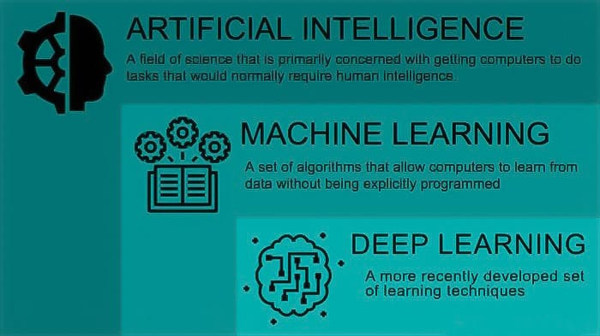 ***Fig 1. MACHINE LEARNING AND AI CONSTRUCTION [21]***

Today we have a huge amount of data. This data is useless unless we properly analyze it and extract information to predict future events and make decisions accordingly. Machine learning techniques are used to automatically identifies the pattern and extract the valuable underlying information from complex data [1]. Programming of a computer so that Machine can learn itself from data in order to make predictions or decisions without being explicitly programmed to do so is called machine learning [2]. For example, the spam filter which flags the spam emails by learning from the spam emails data. This data is called training data. Earlier we used to look for words and phrases (like “4U”, “credit card”,” free” etc.) and few other patterns in the body and sender’s name of the spam email which comes a lot in these spams. Then we write an algorithm to detect these patterns and if your program detects some of these patterns in the email then your program flags email as spam. This makes the program very long and hard to maintain. By using machine learning techniques, we can make a shorter spam filter which is capable of automatically detecting phrases and words which comes a lot in spam emails and makes it easier to maintain. If the spammers make some changes to avoid getting their emails to be flagged like if they start using “For U” instead of “4U” then, spam filter using old techniques of programming need to be updated to flag “For U” emails and had to be updated every time if spammers keep on working to beat our spam filter. Using machine learning techniques spam filter can automatically notice “For U” is coming frequently in spam flagged by a user, and starts flagging that [3].

Machine learning has progressed extremely over the past decades with giant companies like Tesla, Google, Microsoft etc. investing billions in the field of machine learning. Today Machine Learning has become one of the most dominating and powerful technologies. Machine Learning is making our life easier by refining our web results, creating new drugs, detecting online frauds, detecting cancer, recommending videos, self-driving cars, beating world champions in games like Alpha Go and chess and is constantly improving.

TYPES OF MACHINE LEARNING

There are many ways in which the machine learns and understands a human pattern but generally, there are three main categories:

* supervised learning
* unsupervised learning
* reinforcement learning.

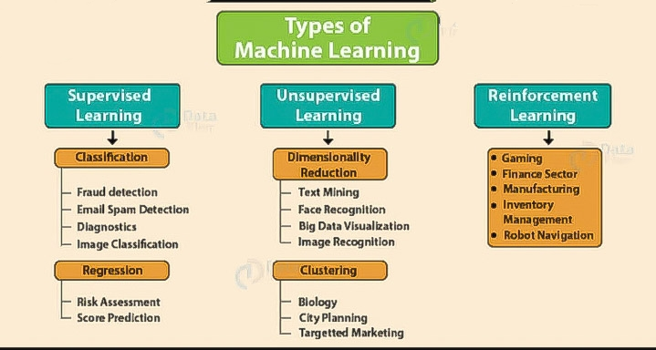 ***Fig 2. TYPES OF MACHINE LEARNING [4]***

**FACE RECOGNITION**

**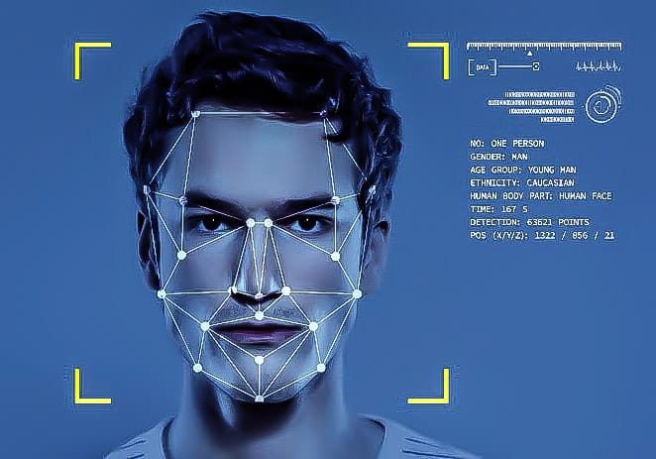 *Fig 4. FACIAL RECOGNITION TECHNOLOGY GENERATES A COMPUTATIONAL MODEL OF A PERSON’S FACE [5]***

INTRODUCTION

Face Recognition is a simple method that that acknowledges a face in a very complicated multidimensional visual model and develops a machine model for it [6]. Face Recognition technology is being used on a large scale in many fields like social media, unlocking smartphones, access control in [security systems](https://en.wikipedia.org/wiki/Burglar_alarm) etc. While using Facebook we might have seen that when we upload a picture an option comes to tag those people who are present in the photo. You may be surprised how come Facebook came to know their id’s just by looking at them? This is done using face recognition technology. When we upload a photo on Facebook, an algorithm is used by this platform which detects faces, and if you click on yes, it creates a link to their profile.

Face Recognition is rising with time and day by day this has been dominating the field of biometric. Development of powerful graphics processing units or GPUs and improvement in big data and deep convolutional neural networks have played a major role in the robust evolution of this technology. Face recognition technology is different from face detection technologies. Face detection just looks for the presence of a human face, while face recognition technology identifies a person with his/her face [7]. In simple words, it is an identification technique which detects faces of an individual whose images is already there in the database. This system can recognize people in video, photos, or in real-time.

Face recognition technology will become more appearing in the near future. [Other countries](http://www.scmp.com/news/china/society/article/2115094/china-build-giant-facial-recognition-database-identify-any) are already using this technology in real-time for example in [sporting events](https://www.sporttechie.com/facial-recognition-technology-tested-lpga-nhl-next/) in the United States. Video cameras that scan the streets for offenders are installed in Moscow and police is also going to be equipped with glasses with the same technology [8]. Other applications of this technology are video surveillance, robotics, automatic indexing of images, mobile platforms and advanced human-computer interaction. There is no doubt that with the rise of this technology world will become more secure as many threats and crimes can be avoided and make this world a better place to live.

HOW DOES THE FACIAL RECOGNITION TECHNOLOGY WORK?

There are many ways in which this system work, but mainly, computer algorithms are used to pick out particular, distinguishing details about an individual’s face and then compare given image with faces present in the [database](https://en.wikipedia.org/wiki/Database_management_system) [9]. It consists of three major steps.

1. Detection of the face:

In the first step, face detection takes place. In this step, the machine finds the presence of a face in the image. If the face is present, then it gives the size and location of the image. Face images may be collected from photos, videos or faces already available on any other website. Obtained face images may have some variations like having the pose, illumination and expression etc. you may be alone or in the crowd but the face is best detected when the person is looking straight [10].

2. Extracting Face Feature:

In the Feature extraction process particular, distinguishing details about a person’s face are taken from a face image using computer algorithms [11]. The machine uses the nodal points for the division of faces into landmarks [10]. These landmarks include some measurements of the face like distance between eyes, depth of the socket and the distance from chin to forehead, the shapes of lips etc. After this, a geometrical representation of the face image called a faceprint or biometric template is created, which is deposited in the database. This result in your facial signature. Later these features are used in the recognition work.

3. Recognition of Face:

This is the final step in which we get to know whose face image is this. In this step, your face print is compared against a database of other face prints. The data of a face is different from a facial image as it only includes specific details that can be used to differentiate between faces. This data is also known as face template. Then it identifies a face in the database which matches the exact features. Some systems tell the probability between the input image and specific face templates. Instead of giving a single result these systems give several potential matches, ranked in order of correctness [10] [11].

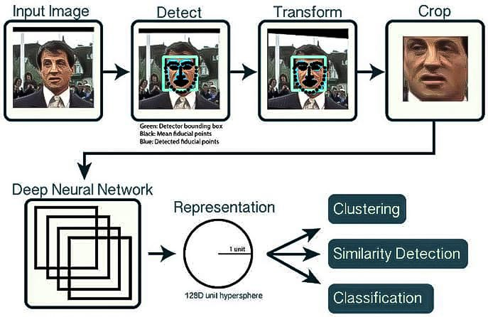 ***Fig 8. WORING OF FACIAL RECOGNITION [12]***

TYPES OF METHODS

Face recognition technology is improving day by day. Optics, computer vision, neural networks, pattern recognition, and many other research areas affect face recognition. Different types of methods for facial recognition are discussed in this section. They use different types of algorithms that support their purpose. The different types of methods are as follows:

1. Geometric/Template Based:

Classification of face recognition methods can be done as geometry based algorithm or template based algorithm. In template based method the image which is inputted is compared with a template set, which can be built by tools like SVM, PCA, LDA, ICA, Kernel Methods or Trace Transforms. Geometric based methods are also known as feature based approach, as local facial features are analysed with their geometric relationships.

The use of this approach has reduced. A recognition system build by algorithms like 3D morphable model style uses PCA and feature points, thus they are developed by using both of these approaches [13].

1. Piecemeal/Holistic Based:

Little information is helpful in identifying a face. Following this idea, some algorithms are processing facial features independently. This approach was followed by many early researchers. Relation between features or the with whole face was not taken into account, trying to find out the most appropriate characteristics. Some approaches were feasible to use a mixture of features, eyes, and some methods like HMM (Hidden Markov Model). Relation between the features is as important as feature processing in face recognition. Most algorithms nowadays follow a holistic approach as the facial features are operated holistically [13].

1. Appearance/Model Based:

Classification of face recognition algorithms can also be done as appearance-based algorithm or model-based algorithms. A face is represented as various raw intensity images and the image is seen as a high dimensional vector in Appearance-based methods. Using statistical techniques feature space from the image distribution is derived and this sample image is compared with training set. Unlike this method, model-based method attempts to model a face image by fitting the new sample to the model. Fitted model parameters are utilized to identify the image [13].

1. Template/Statistical/Neural Network Based:
   1. Template Matching: In this type of approach, the pattern is represented by pixels, samples, textures, models, etc. and the distance or the relation between these templates is recognition function [13].
   2. Statistical Approach: In this type of approach, features express patterns. D features represent each image as the recognition function is a discriminant function [13]. Therefore, for analysis and extraction appropriate statistical tool should be selected and applied. In Facial recognition, we have many statistical tools for the recognition of a face. These tools are- PCA, LDA, Gabor Wavelet, Discrete Cosine Transform, LPP (Locality Preserving Projections), ICA (Independent Component Analysis), Kernel PCA and can be used in two or more grouping methods [14].
   3. Neural Networks: It is a series of algorithms which is capable of recognizing patterns and classify data continuously. Kohonen was the first one to show recognition alignment and normalisation of faces using neural networks. Many methods make a hybrid classifier for the face, using tools like PCA or LDA, which helps in performing feature extraction using neural networks. Multi-layer perception Convolutional Neural Networks and additional biasing Self-Organizing Maps with PCA, has made these algorithms feed forwarding. All of these has resulted in the increased efficiency of models [14].

***TABLE 1. TYPES OF MEHODS WITH THEIR SAMPLE ALGORITHMS [15]***

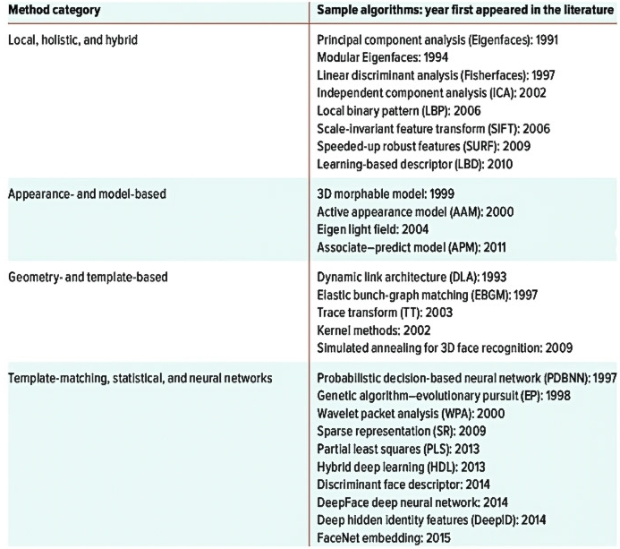

APPLICATIONS OF FACIAL RECOGNITION TECHNOLOGY

* Face recognition can help in finding missing individuals. Using photos of that missing person, face recognition system can identify that person in a CCTV footage and help the police by giving location at the earliest. This can save a lot of time in severe cases like kidnappings [16].
* Face recognition CCTV can help in identifying and tracking criminals suspected of making an immoral action and take preventive actions at the earliest. By using images of people having a record of crime, police or other agencies can detect these pictures in real-time and take actions before it is too late [16].
* Drones with cameras can be used in concerts or mass events to ensure the security of people and can help in identifying the presence of any criminal or terrorists. Face recognition technology can also help in finding out wanted criminals or terrorists as well as track their movement.
* Face recognition system can also be used to mark attendance in schools and colleges. This will restrict students from marking proxies and false attendance when they are not present and they won’t bunk classes [17].
* This is also helping various companies to secure their premises by controlling the access of the locations where only authorised people are allowed. we can also whitelist or blacklist an individual for specific locations [17].
* Face unlocking feature of face recognition has already made our mobile phones secure.
* This technology can also make advertisements more targeted. Using face recognition wage group of a person can be identified and only those advertisements are shown which are suitable for that person hence making advertisement smarter [17].

***TABLE 2. APPLICATIONS OF FACIAL RECOGNITIONTECHNOLOGY [18]***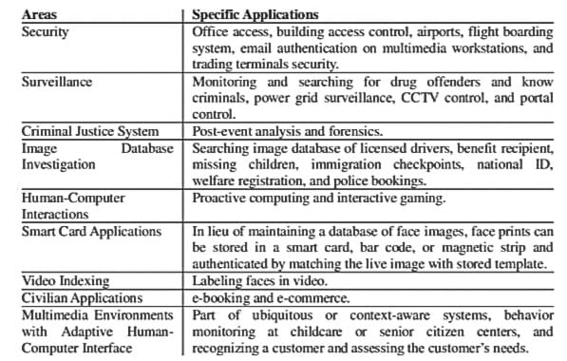

LIMITATIONS OF FACIAL RECOGNITION TECHNOLOGY

* Facial recognition software primarily depends on 2D images for the sake of convenience. As most of the cameras are not capable of capturing photos with any depth, and photos already available are in 2D (for example on Facebook). This reduces the accuracy as a flat image of face lacks features, like your nose length [19].
* 2D facial imaging won’t work in the dark as it depends on visible light spectrum, and we cannot rely on this in shadowy and poor lighting conditions [19].
* Image quality affects the working of face recognition technology. Use of low-end cameras in security system hampers the effectiveness of this technology.
* Large storage capacity is required as the image samples stored of a person contain images with different angles which requires huge investments [20].
* The angle of the facial image also influences the face recognition system’s accuracy. Usually, multiple angles are used to enrol a face in recognition software. If the image does not match the angle of the sample image it would affect the systems recognition ability.

HOW TO OVERCOME THESE LIMITATIONS?

These limitations are resolved by using IR cameras and thermal imaging and by installing high definition cameras and using more security cameras. Face scanning devices projects an IR matrix at the selected face and uses the information gained to build a unique template of the face selected which significantly increase the accuracy of facial recognition software. Thermal imaging cameras detect the IR light that emits from the object which is used to find the distance between facial organs which helps in recognising faces [19]. To deal with the storage issues Clusters of computers have to be set up with proper security and the ability to store huge amounts of data.

Some of these limitations will be solved as the technology improves. The mechanism will improve that will beat today’s algorithms, and obscuring parts of face with mask and sunglasses or changing hairstyles, expressions will not decrease the accuracy of facial recognition system [20].

CONCLUSION

Facial recognition is a very emerging field and will be more efficient with the advancement of technology. This technology has drawn huge attention of law enforcement agencies and will soon help to create a safer world. Every method discussed has its own specialisation under certain conditions. Method using Deep Neural Network is more efficient for example the DeepFace system based on convolutional neural network recognizes a face in digital images with an accuracy of 97%. It was developed by a Facebook research group. It was a major step using deep learning for face recognition. We also saw some limitations but we can overcome those shortly. Soon it would find its way to many fields like ATM’s, accessing confidential files, passwords, to use the face as credit cards. This technology holds a lot of potentials and would simplify the process and improve the flow of traffic significantly.

REFERENCES

1. towards data science 2018. Machine Learning | An introduction [HTML document]. Retrieved [17.4.'20] from the World Wide Web,<https://towardsdatascience.com/machine-learning-an-introduction-23b84d51e6d0>
2. EXPERT SYSTEM 2020. What is Machine Learning? A definition [HTML document]. Retrieved [17.4.'20] from the World Wide Web, <https://expertsystem.com/machine-learning-definition/>
3. Aurelien Geron(n.y.), Hands on Machine Learning with Scikit-Learn, Keras & Tensorflow [HTML document]. Retrieved [17.4.'20] from the World Wide Web, [http://index-of.es/Varios-2/Hands%20on%20Machine%20Learning%20with%20Scikit%20Learn%20 and%20Tensorflow.pdf](http://index-of.es/Varios-2/Hands%20on%20Machine%20Learning%20with%20Scikit%20Learn%20%20and%20Tensorflow.pdf)
4. Data Flair 2019. Learn Types of Machine Learning Algorithms with Ultimate Use Cases [HTML document]. Retrieved [23.4.'20] from the World Wide Web, <https://data-flair.training/blogs/types-of-machine-learning-algorithms/>
5. analyticsindiamag 2020, TOP 7 RESOURCES TO LEARN FACIAL RECOGNITION [HTML document]. Retrieved [23.4.'20] from the World Wide Web, <https://analyticsindiamag.com/top-7-resources-to-learn-facial-recognition/>
6. IJCTT 2013. Literature Survey on Face Recognition Techniques [HTML document]. Retrieved [23.4.'20] from the World Wide Web, <http://ijcttjournal.org/Volume5/number-4/IJCTT-V5N4P136.pdf>
7. FACEFIRST 2017. FACE DETECTION VS. FACE RECOGNITION [HTML document]. Retrieved [23.4.'20] from the World Wide Web, <https://www.facefirst.com/blog/face-detection-vs-face-recognition/>
8. The Guardian 2019.What is facial recognition - and how sinister is it? [HTML document]. Retrieved [23.4.'20] from the World Wide Web, <https://www.theguardian.com/technology/2019/jul/29/what-is-facial-recognition-and-how-sinister-is-it>
9. WIKIPIDEA 2020. Facial recognition system [HTML document]. Retrieved [2.5.'20] from the World Wide Web, <https://en.wikipedia.org/wiki/Facial_recognition_system>
10. panda 2019, Complete Guide to Facial Recognition Technology. How Does Facial Recognition Work? [HTML document]. Retrieved [2.5.'20] from the World Wide Web, <https://www.pandasecurity.com/mediacenter/panda-security/facial-recognition-technology/>
11. ELECTRONIC FRONTIER FOUNDATION (n.y.), STREET LEVEL SURVEILLANCE. Face Recognition [HTML document]. Retrieved [2.5.'20] from the World Wide Web, <https://www.eff.org/pages/face-recognition>
12. pyimagesearch 2018, OpenCV Face Recognition [HTML document]. Retrieved [2.5.'20] from the World Wide Web, <https://www.pyimagesearch.com/2018/09/24/opencv-face-recognition/>
13. IJEERT 2014, Face Recognition with Different Approaches: A Survey [HTML document]. Retrieved [2.5.'20] from the World Wide Web, <http://www.ijeert.org/pdf/v2-i7/39.pdf>
14. towards data science 2018. Face Recognition for Beginners [HTML document]. Retrieved [2.5.'20] from the World Wide Web, <https://towardsdatascience.com/face-recognition-for-beginners-a7a9bd5eb5c2>
15. ResearchGate 2017, A Face in any Form: New Challenges and Opportunities for Face Recognition Challenges [HTML document]. Retrieved [2.5.'20] from the World Wide Web,<https://www.researchgate.net/publication/316496813_A_Face_in_any_Form_New_Challenges_and_Opportunities_for_Face_Recognition_Technology>
16. Thalesgroup 2020, Facial recognition: top 7 trends (tech, vendors, markets, use cases and latest news) [HTML document]. Retrieved [7.5.'20] from the World Wide Web, [https://www.thalesgroup.com/en/markets/digital-identity-and-security/government/biometrics /facial-recognition](https://www.thalesgroup.com/en/markets/digital-identity-and-security/government/biometrics%20/facial-recognition)
17. FACEFIRST 2018, 21 AMAZING USES FOR FACE RECOGNITION – FACIAL RECOGNITION USE CASES [HTML document]. Retrieved [7.5.'20] from the World Wide Web, <https://www.facefirst.com/blog/amazing-uses-for-face-recognition-facial-recognition-use-cases/>
18. ResearchGate 2016, Improve Face Recognition Rate Using Different Image Pre-Processing Techniques [HTML document]. Retrieved [7.5.'20] from the World Wide Web,<https://www.researchgate.net/publication/301282426_Improve_Face_Recognition_Rate_Using_Different_Image_Pre-Processing_Techniques>
19. howtogeek 2019, How Does Facial Recognition Work? [HTML document]. Retrieved [7.5.'20] from the World Wide Web, <https://www.howtogeek.com/427897/how-does-facial-recognition-work/>
20. FedTech 2013, 4 Limitations of Facial Recognition Technology [HTML document]. Retrieved [7.5.'20] from the World Wide Web, <https://fedtechmagazine.com/article/2013/11/4-limitations-facial-recognition-technology>
21. Connect&Construct 2018, What is AI and Machine Learning in Construction? Our Definitive Answer [HTML document]. Retrieved [7.5.'20] from the World Wide Web, <https://connect.bim360.autodesk.com/what-is-machine-learning-in-construction>